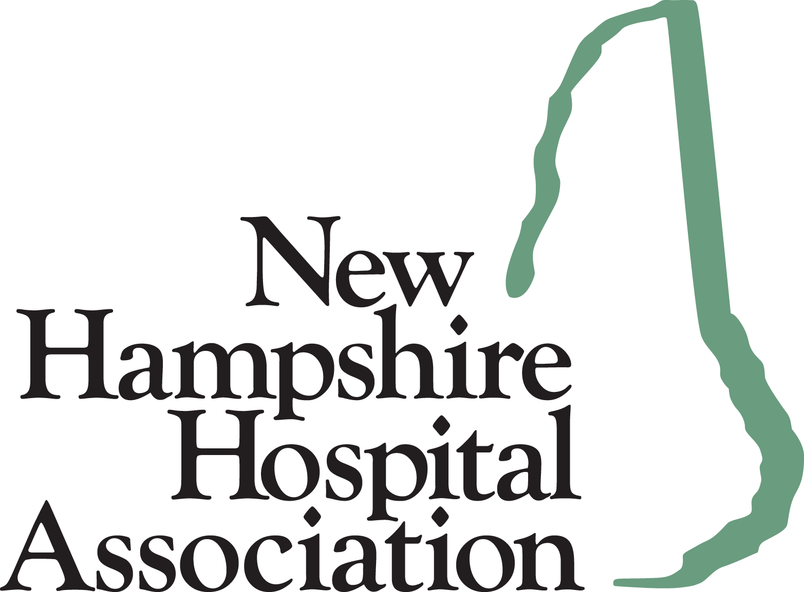

January 18, 2022

Allyson Zinno
Administrator
Administrative Rules Unit
Department of Health and Human Services
129 Pleasant Street, 2nd Floor
Concord, NH 03301
(SENT via email to: Allyson.E.Zinno@dhhs.nh.gov)
Dear Ms. Zinno:
Please accept this letter of support for proposed rule changes set forth in He-P 309, Healthcare Associated Infections Reporting.
As noted in the proposed rules summary, the changes to the He-P 309 rules are needed, in part, due to the passage of HB 131 from the 2021 legislative session (Chapter 79 of the Laws of 2021), which removed the requirement to identifying, tracking, and reporting process measures as it relates to surgical antimicrobial prophylaxis (SCIP) data.
Thank you for your partnership and collaboration in supporting New Hampshire’s hospitals and making the necessary changes to the Healthcare Associated Infections rules to be in line with the current statute.

Sincerely,
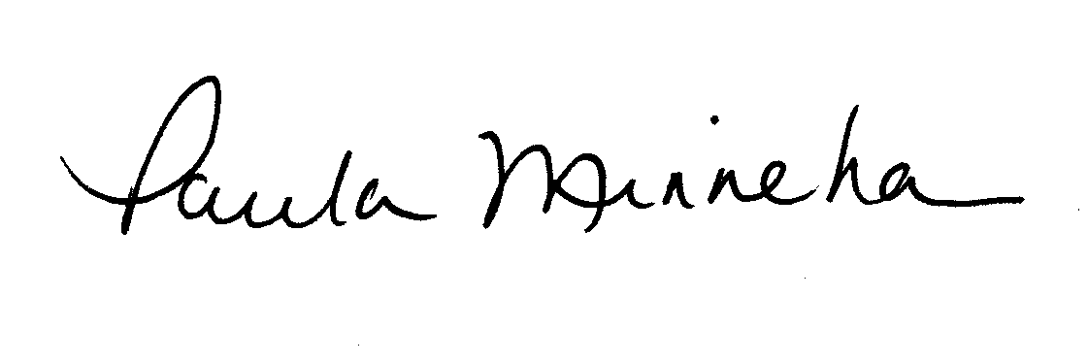
Paula M. Minnehan
SVP, State Government Relations

